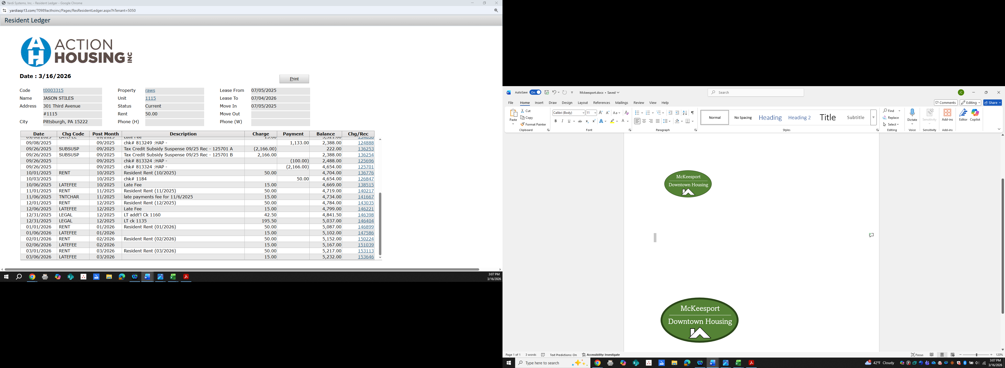
McKeesport Downtown Housing
Address: 523 Sinclair St, McKeesport, PA 15132
Phone: (412) 281-2102

Contact: Dawn Taylor
Tel: 412-765-2532 ext 202
DTAYLOR@SHMS-ACTIONHOUSING.ORG

Project Based Homeless (non-portable voucher) – Male and Female units
APPLICATION WILL NOT BE SUBMITTED TO
MCKEESPORT DOWNTOWN HOUSING AUTHORITY
UNTIL ALL REQUIRED DOCUMENTATION IS PROVIDED.

Homeless Section 8 Units Available
Proof of any income
- Current Social Security award letter dated within 60 days of application
- Current Paystubs
- Current COMPASS EBT Report
- If you have ZERO INCOME – MCKEESPORT HOUSING AUTHORITY VERIFICTION OF ZERO INCOME FORM MUST BE COMPLETED AND NOTARIZED.
Must provide
- Valid Photo ID
- Social Security Card

